**Computer Programming Lab**

**Lab Journal - 6**

Name: Mohammad Arsalan Shakil

Enrollment #: 01-134181-032

Date: 20-03-2018

**Objective:**

1) Understanding Looping Statements

2) Revising Loops and different Nested structures

**Tools Required:**

1. PC with Windows 7 Professional or onwards
2. Visual Studio 2013 onwards

**Task 1:**Run the Following Code, understand and dry-run it and seeit’s output:

#include <iostream>

using namespace std;

int main()

{

Int rows, coef=1,space,i,j;

cout<<"Enter number of rows: ";

cin>>rows;

for(i=0;i<rows; i++)

{

for(space=1;space<=rows-i; space++)

cout<<" ";

for(j=0;j<=i; j++)

{

if (j==0||i==0)

coef=1;

else

coef=coef*(i-j+1)/j;

cout<<" "<<coef;

}

cout<<endl;

}

}

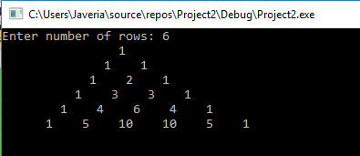

**It should show something like the following. It is known as Pascal’s Triangle.**

1

1 1

1 2 1

1 3 3 1

1 4 6 4 1

1 5 10 10 5 1

**Understand and dry run the above code and paste your Output here :**

|  |  |  |  |  |  |  |  |  |  |  |  |  |  |  |  |  |  |  |  |  |  |  |  |  |  |  |  |  |  |  |  |  |  |  |  |  |  |  |  |  |  |  |  |  |  |  |  |  |  |  |  |  |  |  |  |  |  |  |  |  |  |  |  |  |  |  |  |  |  |  |  |  |  |  |  |  |  |  |  |  |  |  |  |  |  |  |  |  |  |  |  |  |  |  |  |  |  |  |  |  |  |  |  |  |  |  |  |  |  |  |  |  |  |  |  |  |  |  |  |  |  |  |  |  |  |  |  |  |  |  |  |  |  |  |  |  |  |  |  |  |  |  |  |  |  |  |  |  |  |  |  |  |  |  |  |  |  |  |  |  |  |  |  |  |  |  |  |  |  |  |  |  |  |  |  |  |  |  |  |  |  |  |  |  |  |  |  |  |  |  |  |  |  |  |  |  |  |  |  |  |  |  |  |  |  |  |  |  |  |  |  |  |  |  |  |  |  |  |  |  |  |  |  |  |  |  |  |  |  |  |  |  |  |  |  |  |  |  |  |  |  |  |  |  |  |  |  |  |  |  |  |  |  |  |  |  |  |  |  |  |  |  |  |  |  |  |  |  |  |  |  |  |  |  |  |  |  |  |  |  |  |  |  |  |  |  |  |  |  |  |  |  |  |  |  |  |  |  |  |  |  |  |  |  |  |  |  |  |  |  |  |  |  |  |  |  |  |  |  |  |  |  |  |  |  |  |  |  |  |  |  |  |  |  |  |  |  |  |  |  |  |  |  |  |  |  |  |  |  |  |  |  |  |  |  |  |  |  |  |  |  |  |  |  |  |  |  |  |  |  |  |  |  |  |  |  |  |  |  |  |  |  |  |  |  |  |  |  |  |  |  |  |  |  |  |  |  |  |  |  |  |  |  |  |  |  |  |  |  |  |  |  |  |  |  |
| --- | --- | --- | --- | --- | --- | --- | --- | --- | --- | --- | --- | --- | --- | --- | --- | --- | --- | --- | --- | --- | --- | --- | --- | --- | --- | --- | --- | --- | --- | --- | --- | --- | --- | --- | --- | --- | --- | --- | --- | --- | --- | --- | --- | --- | --- | --- | --- | --- | --- | --- | --- | --- | --- | --- | --- | --- | --- | --- | --- | --- | --- | --- | --- | --- | --- | --- | --- | --- | --- | --- | --- | --- | --- | --- | --- | --- | --- | --- | --- | --- | --- | --- | --- | --- | --- | --- | --- | --- | --- | --- | --- | --- | --- | --- | --- | --- | --- | --- | --- | --- | --- | --- | --- | --- | --- | --- | --- | --- | --- | --- | --- | --- | --- | --- | --- | --- | --- | --- | --- | --- | --- | --- | --- | --- | --- | --- | --- | --- | --- | --- | --- | --- | --- | --- | --- | --- | --- | --- | --- | --- | --- | --- | --- | --- | --- | --- | --- | --- | --- | --- | --- | --- | --- | --- | --- | --- | --- | --- | --- | --- | --- | --- | --- | --- | --- | --- | --- | --- | --- | --- | --- | --- | --- | --- | --- | --- | --- | --- | --- | --- | --- | --- | --- | --- | --- | --- | --- | --- | --- | --- | --- | --- | --- | --- | --- | --- | --- | --- | --- | --- | --- | --- | --- | --- | --- | --- | --- | --- | --- | --- | --- | --- | --- | --- | --- | --- | --- | --- | --- | --- | --- | --- | --- | --- | --- | --- | --- | --- | --- | --- | --- | --- | --- | --- | --- | --- | --- | --- | --- | --- | --- | --- | --- | --- | --- | --- | --- | --- | --- | --- | --- | --- | --- | --- | --- | --- | --- | --- | --- | --- | --- | --- | --- | --- | --- | --- | --- | --- | --- | --- | --- | --- | --- | --- | --- | --- | --- | --- | --- | --- | --- | --- | --- | --- | --- | --- | --- | --- | --- | --- | --- | --- | --- | --- | --- | --- | --- | --- | --- | --- | --- | --- | --- | --- | --- | --- | --- | --- | --- | --- | --- | --- | --- | --- | --- | --- | --- | --- | --- | --- | --- | --- | --- | --- | --- | --- | --- | --- | --- | --- | --- | --- | --- | --- | --- | --- | --- | --- | --- | --- | --- | --- | --- | --- | --- | --- | --- | --- | --- | --- | --- | --- | --- | --- | --- | --- | --- | --- | --- | --- | --- | --- | --- | --- | --- | --- | --- | --- | --- | --- | --- | --- | --- | --- | --- | --- | --- | --- | --- | --- | --- | --- | --- | --- | --- | --- | --- | --- | --- | --- | --- | --- | --- | --- | --- | --- | --- | --- | --- | --- | --- | --- | --- | --- | --- | --- | --- | --- | --- | --- | --- | --- | --- | --- | --- |
| |  |  |  |  |  | | --- | --- | --- | --- | --- | | rows | coef | space | i | j | |  | 1 |  |  |  | | 6 |  |  |  |  | | 6 |  |  | 0 |  | | 6 |  | 1 |  |  | | 6 |  | 2 |  |  | | 6 |  | 3 |  |  | | 6 |  | 4 |  |  | | 6 |  | 5 |  |  | | 6 |  | 6 |  |  | |  |  | 7 |  |  | |  |  |  | 0 | 0 | |  | 1 |  |  |  | |  |  |  | 0 | 1 | | 6 |  |  | 1 |  | | 5 |  | 1 |  |  | | 5 |  | 2 |  |  | | 5 |  | 3 |  |  | | 5 |  | 4 |  |  | | 5 |  | 5 |  |  | | 5 |  | 6 |  |  | |  |  |  | 1 | 0 | |  | 1 |  |  |  | |  |  |  | 1 | 1 | |  | 1 |  |  |  | |  |  |  | 1 | 2 | | 6 |  |  | 2 |  | | 4 |  | 1 |  |  | | 4 |  | 2 |  |  | | 4 |  | 3 |  |  | | 4 |  | 4 |  |  | |  |  | 5 |  |  | |  |  |  | 2 | 0 | |  | 1 |  |  |  | |  |  |  | 2 | 1 | |  | 2 |  |  |  | |  |  |  | 2 | 2 | | 6 |  |  | 3 |  | | 3 |  | 1 |  |  | | 3 |  | 2 |  |  | | 3 |  | 3 |  |  | |  |  | 4 |  |  | |  |  |  | 3 | 0 | |  | 1 |  |  |  | |  |  |  | 3 | 1 | |  | 3 |  |  |  | |  |  |  | 3 | 2 | |  | 3 |  |  |  | |  |  |  | 3 | 3 | |  | 1 |  |  |  | |  |  |  | 3 | 4 | | 6 |  |  | 4 |  | | 2 |  | 1 |  |  | | 2 |  | 2 |  |  | |  |  | 3 |  |  | |  |  |  | 4 | 0 | |  | 1 |  |  |  | |  |  |  | 4 | 1 | |  | 4 |  |  |  | |  |  |  | 4 | 2 | |  | 6 |  |  |  | |  |  |  | 4 | 3 | |  | 4 |  |  |  | |  |  |  | 4 | 4 | |  | 1 |  |  |  | |  |  |  | 4 | 5 | | 6 |  |  | 5 |  | | 1 |  | 1 |  |  | |  |  | 2 |  |  | |  |  |  | 5 | 0 | |  | 1 |  |  |  | |  |  |  | 5 | 1 | |  | 5 |  |  |  | |  |  |  | 5 | 2 | |  | 10 |  |  |  | |  |  |  | 5 | 3 | |  | 10 |  |  |  | |  |  |  | 5 | 4 | |  | 5 |  |  |  | |  |  |  | 5 | 5 | |  | 1 |  |  |  | |  |  |  | 5 | 6 | |  |  |  | 7 |  | |

**Task 2 :**

You have a client who wants you to automate transactions for his bank.You have to write a program in C++ for his bank.

Your program should start and welcome the user. Then ask the user to Enter Account Number.After that give him four options and ask him to choose.“What do you want to do? Deposit Money, Withdraw Money, Check balance or No transaction”. If he chooses Deposit Money, ask the amount to deposit and add it in the balance variable. If he chooses Withdraw, ask the amount to withdraw and subtract it from the balance variable. If he chooses Check balance, display the account number and the value of balance variable on screen. The loop should keep on repeating and continue asking the user “What do you want to do?? It should never end until the user Enter the fourth option that is No transaction. Use while loop for this feature.

At the end of program #(when the loop for transactions has ended) ask the user, do you want to continue with another account number? Yes or no. If the user enter y for yes program should repeat again. If the user enters no program should end. Use do while loop for this feature.

Note: Clean the screen every time for a new transaction or for a new account. Display should be very neat and good for your program. Two Sample outputs are s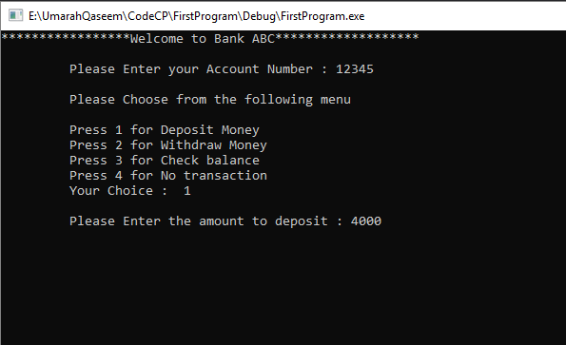  
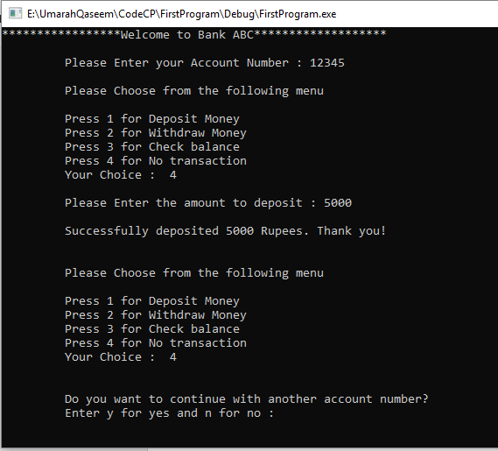

**Code:**

#include<iostream>

#include<conio.h>

using namespace std;

void main()

{

cout << "********************Welcome to ABC Bank********************" << endl << endl;

cout << "Press Y to continue" << endl;

char x, y;

cin >> x;

while (x == 'y')

{

do

{

int acc_num;

cout << "Enter Account Number : ";

cin >> acc_num;

int balance = 0;

cout << "Enter Password : ";

int acc_pass;

cin >> acc_pass;

if (acc_pass == 12345)

{

cout << "Please choose from the following Menu" << endl << endl;

cout << "Press 1 for Deposit \nPress 2 for Withdraw \nPress 3 for Balance \nPress 4 for No transaction " << endl;

int k;

cin >> k;

int deposit, withdraw;

switch (k)

{

case (1):

cout << "Enter Deposit Amount : ";

cin >> deposit;

balance = balance + deposit;

cout << endl << "Transaction Successful" << endl;

cout << "Your new Balance is : " << balance << endl;

break;

case (2):

cout << "Enter Withdraw Amount : ";

cin >> withdraw;

if (balance < withdraw)

{

cout << "Insufficient Amount" << endl;

}

else

{

balance = balance - withdraw;

cout << "Your account has been deducted by " << withdraw << endl;

cout << "Your Remaining Balance is " << balance << endl << endl;

}

break;

case (3):

cout << "Your balance is : " << balance << endl;

break;

case (4):

cout << "Thank you for Using";

break;

default:

cout << "Wrong Choice";

}

}

else

cout << "Wrong Password" << endl;

cout << "Do you want to continue with another account?"<<endl;

cout << "Press Y for Yes and N for No : ";

cin >> y;

}

while (y == 'y');

}

_getch();

}

**Output:**

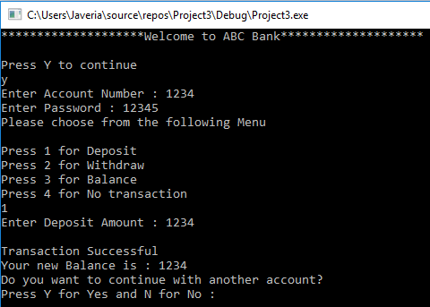

**Task 3 :**

Write a program that has an infinite loop and it takes integer input from user. If the user enters 1 it clears the screen, if he enters 2 it breaks that infinite loop, it he enters 3 it exits the program, if he enters 4 it waits for any character input from keyboard and then exit the program.

**Write code in c++ using nested loops to display the following patterns on the screen. Paste their code aswell as output below.**

**Code :**

**Output :**

**Task 4 :**

54321  
54321  
54321  
54321  
54321

**CODE :**

#include <iostream>

#include <conio.h>

using namespace std;

int main()

{

int i, j;

for (i=1; i <= 5; i++)

{

for (j=5; j >= 1; j--)

{

cout << j;

}

cout << endl;

}

_getch();

return 0;

}

**OUTPUT :**

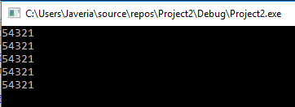

**Task 5:**

*

* * *

* * * * *

* * * * * * *

* * * * * * * * *

**CODE:**

#include <iostream>

#include <conio.h>

using namespace std;

int main()

{

int space, rows=5;

for (int i = 1; i <= rows; ++i)

{

for (space = 1; space <= rows - i; ++space)

{

cout << " ";

}

for (int k = 0; k <= i; ++k)

while (k != 2 * i - 1)

{

cout << "* ";

++k;

}

cout << endl;

}

_getch();

return 0;

}

**OUTPUT:**

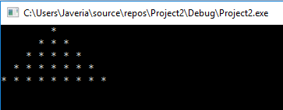

**Task 6:**

* * * * * * * * *

* * * * * * *

* * * * *

* * *

*

**CODE:**

#include <iostream>

#include <conio.h>

using namespace std;

int main()

{

int i, j;

for (int i = 5; i >= 1; --i)

{

for (int space = 0; space < 5 - i; ++space)

cout << " ";

for (int j = i; j <= 2 * i - 1; ++j)

cout << "* ";

for (int j = 0; j < i - 1; ++j)

cout << "* ";

cout << endl;

}

_getch();

return 0;

}

**OUTPUT:**

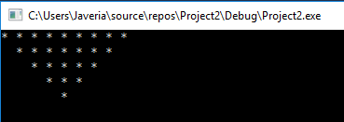

**Bonus Task:**

1

2 3 2

3 4 5 4 3

4 5 6 7 6 5 4

5 6 7 8 9 8 7 6 5

**CODE:**

#include<iostream>

#include<conio.h>

using namespace std;

void main()

{

int i, j, a = 1, n=5, s;

s = n; //s is for printing number of space

while (s != 0) //while loop to print the space

{

cout << " ";

s--;

}

cout << a << "\n";

for (i = 1; i<n; i++) //This is outer loop for number of rows

{

s = n - i;

while (s != 0) //while loop for printing space

{

cout << " ";

s--;

}

for (j = 0; j <= i * 2; j++) //Inner loop for printing pattern

{

if (j <= i)

{

a++;

cout << a;

}

else

{

a--;

cout << a;

}

}

cout << "\n";

}

_getch();

}

**OUTPUT:**



